

INSTITUITON: DEDAN KIMATHI UNIVERSITY OF TECHNOLOGY
COURSE: BSc IN ELECTRICAL AND ELECTRONICS ENGINEERING
UNIT NAME: EEE 5107 ARTIFICIAL INTELLIGENCE AND MACHINE LEARNING.
TASK:TO CREATE A FRUIT-VEGETABLE CLASSIFIER MODEL IN CNN USING TENSORFLOW.
DATE :18/06/2024
GROUP MEMBERS
NAME | REG NUMBER | SIGN
RICHARD OGOLA | E021-01-2259/2020
PETER MAINA | E021-01-0942/2020
MERCY BORE | E021-01-0993/2020
MERCY EDWIN | E021-01-2395/2020
MICHAEL MWAURA | E021-01-0939/2020

AIMS AND OBJECTIVE
To create a fruit-vegetable classifier in CNN using TensorFlow.

SOFTWARE, IDE AND LIBRARY USED.
- Google colab:This is hosted Jupyter notebook service that requires no setup to use and provides free access to computing resources including GPUs and TPU.
- TensorFlow: TensorFlow is a free and open-source software library for machine learning and artificial intelligence. It can be used across a range of tasks but has a particular focus on training and inference of deep neural networks.
- Keras: Keras is an open-source library that provides a Python interface for artificial neural networks. "Keras 3 is a full rewrite of Keras [and can be used] as a low-level cross-framework language to develop custom components such as layers, models, or metrics that can be used in native workflows in JAX, TensorFlow, or PyTorch.
PROCEDURE.
1.We first collected data samples in our case Image sets of various fruits and vegetables locally and some in naivas supermarket, Nyeri branch on the grocery section as well as Nyeri market.
2.We labelled each dataset, named (image annotation) and converted all the images to JPG. and created a folder as well as a directory to our dataset path in our desktop.
A link to the dataset; https://drive.google.com/drive/folders/1OAWtMJs18qwzBkSzgasdJQ0Cu4SvyFJu
3.We used Google collab as our IDE and opened a new notebook titled “fruits and vegies classification lab project ML.ipynb” then uploaded the folder with our dataset to our google drive and mounted it to our google collab working directory and unzip the files .
4.Importing libraries; Libraries such as OS, random, NumPy, matplotlib, cv2 and TensorFlow. keras.preprocessing are imported. And specify the Dataset path to the fruit dataset i.e. training folder and test folders.
A link to the google collab working notebook:https://drive.google.com/drive/folders/1OAWtMJs18qwzBkSzgasdJQ0Cu4SvyFJu
5.Visualizing our dataset paths i.e. counting the labels and performing randomness and visualize the contents of our data randomly.
6.Data Preprocessing; Define constants for batch size, image size (height and width), converting the images to NumPy arrays known as tensors.We also did data Augmentation which is a technique used to artificially increase the diversity of your training dataset without actually collecting new data. It involves applying random transformations to the existing images in your dataset. We also did data normalisation which is the process of translating the into a range of [0 1] in our case rescaling by /255.
7.Optimizing datasets for training; Try to lower the learning rate so as to set the parameters,and use of a cost function which is a mathematical concept that is associated with how supervised learning adjusts the weights to reduce the error of the training data. In this context, the measure of the neural network’s error is the cost function. The greater the error of the neural network, the higher the value of the cost function
During training, the training data is presented in batches to the network. This often happens in a fixed order over all iterations. This may lead to certain biases in the network.
First of all, we made sure that the training data is shuffled at least once to avoid the network unlearning much of the first class by the end of each epoch.
Also, reshuffle the training data between epochs. This will again avoid potential minor biases because of training data order.
8.Model Architecture
8.1 We started by initializing the CNN And adding a convolution layer, each layer had a filter/kernel, kernel-size, activation function and an input shape, dropout while the output shape
8.2 During training we defined the optimizer and the loss functions to be Adam and categorical_crossentropy.
8.3 Compiled and trained the model; We fit the model on training set

9.Evaluating the model’s performance; We used accuracy as a metric to evaluate the performance of the CNN. After fitting the model on the training dataset, we compare the accuracy and loss for both training and test datasets.
10.Visualizing the model’s performance
11.load and save the model ;The link to the trained model ;https://drive.google.com/file/d/1lPQot22I74civUL2H0iXTWzVloLRSRK1/view?usp=drivesdk

THEORY
Convolutional Neural Networks(CNN) is a type of deep learning model for processing data that has a grid pattern, such as images, which is inspired by the organization of animal visual cortex and designed to learn spatial hierarchies of features automatically and adaptively, from low- to high-level patterns. CNN is a mathematical construct that is typically composed of three types of layers (or building blocks): convolution, pooling, and fully connected layers. The first two, convolution and pooling layers, perform feature extraction, whereas the third, a fully connected layer, maps the extracted features into final output, such as classification. In digital images, pixel values are stored in a two-dimensional (2D) grid, i.e., an array of numbers and a small grid of parameters called kernel, an optimizable feature extractor, is applied at each image position, which makes CNNs highly efficient for image processing, since a feature may occur anywhere in the image. As one layer feeds its output into the next layer, extracted features can hierarchically and progressively become more complex. The process of optimizing parameters such as kernels is called training, which is performed so as to minimize the difference between outputs and ground truth labels.
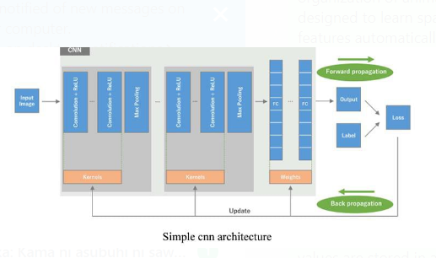

We first need to initiate sequential class since there are various layers to build CNN which all must be in sequence. Then we add the first convolutional layer where we need to specify 4 arguments.
1)Filters
The primary purpose of convolution is to find features in the image using a feature detector. Then put them into a feature map, which preserves distinct features of images.
Feature detector which is known as a filter also is initialized randomly and then after a lot of iteration, filter matrix parameter selected which will be best for separating images. For instance, animals’ eye, nose, etc. will be considered as a feature which is used for classifying images using filter or feature detectors. Here we are using 16 features.
2)Kernel_size
Kernel_size refers to filter matrix size. Here we are using a 3*3 filter size.The kernel is used to extract high-level features like edges from the image.
- Padding;Padding in CNN refers to the addition of extra pixels around the borders of the input images or feature map. This process removes aggregation bias from the convolution operation, it makes sure every pixel gets considered.
- Activation Function-Relu
Since images are non-linear, to bring non-linearity, the relu activation function is applied after the convolutional operation.
Relu stands for Rectified linear activation function. Relu function will output the input directly if it is positive, otherwise, it will output zero.

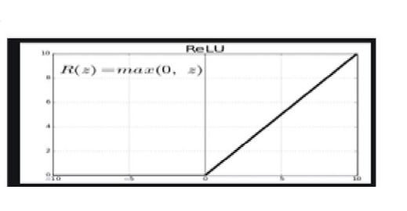
- Input shape;As input, a CNN takes tensors of shape (image_height, image_width, color_channels), In our case (150,150,3) ignoring the batch size.,our colour channel was RGB.
- Pooling Operation;Pooling is an operation of down sampling of the image. The pooling layer is used to reduce the dimensions of the feature maps. Thus, the Pooling layer reduces the number of parameters to learn and reduces computation in the neural network and makes it more Robust.
- Dropout;This is the process of dropping certain nodes in a layer at random during training in our case we used 0.5 I.e dropping half of the neurons in the layer during training.
- Flattening operation;The output feature maps of the final convolution or pooling layer is typically flattened, i.e., transformed into a one-dimensional (1D) array of numbers (or vector).
- Fully connected layer and the output layer
Once the features extracted by the convolution layers and downsampled by the pooling layers are created, they are mapped by a subset of fully connected layers to the final outputs of the network, such as the probabilities for each class in classification tasks. The final fully connected layer typically has the same number of output nodes as the number of classes. The activation function applied to the last fully connected layer is usually different from the others. An appropriate activation function needs to be selected according to each task. An activation function applied to the multiclass classification task is a softmax function which normalizes output real values from the last fully connected layer to target class probabilities, where each value ranges between 0 and 1 and all values sum to 1

- Optimizer
Optimization is an important component of the training process, as it involves finding the optimal set of parameters for the model that can minimize the loss or error on the training data.
We used Adam A (Adaptive Moment Estimation) is an optimization algorithm used in machine learning and deep learning to optimize the training of neural networks.
Adam combines the concepts of both momentum and RMSProp. It maintains a moving average of the gradient's first and second moments, which are the mean and variance of the gradients, respectively. The moving average of the first moment, which is similar to the momentum term in other optimization algorithms, helps the optimizer to continue moving in the same direction even when the gradients become smaller. The moving average of the second moment, which is similar to the RMSProp term, helps the optimizer to scale the learning rate for each parameter based on the variance of the gradients.
Adam also includes a bias correction step to adjust the moving averages since they are biased towards zero at the beginning of the optimization process. This helps to improve the optimization algorithm's performance in the early stages of training.
Adam is a popular optimization algorithm due to its ability to converge quickly and handle noisy or sparse gradients. Additionally, it does not require manual tuning of hyperparameters like the learning rate decay or momentum coefficient, making it easier to use than other optimization algorithms.
Overall, Adam is a powerful optimization algorithm that can help accelerate the training of deep neural networks and improve their performance.
We also incorporated a learning rate of 0.001,Lr is a tuning parameter in an optimization algorithm that determines the step size at each iteration while moving toward a minimum of a loss function.

RESULTS AND DATA ANALYSIS.
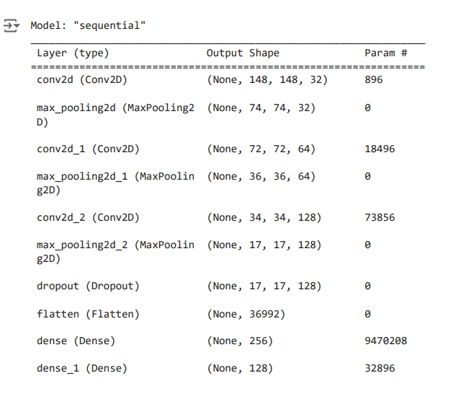

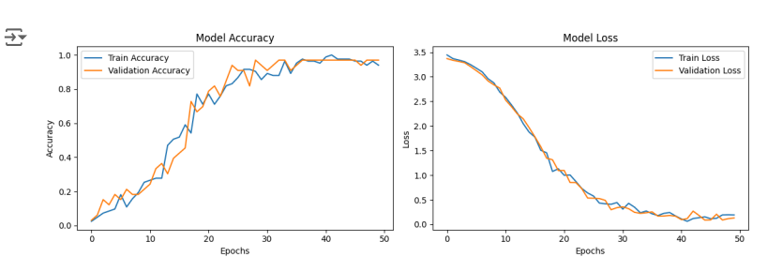model Accuracy is the measure of how well our model predicts by comparing the model predictions with the true values
The loss is calculated on training and validation and its interpretation is how well the model is doing for these two sets. Unlike accuracy, loss is not a percentage. It is a summation of the errors made for each example in training or validation sets
We realized that the loss value was not decreasing an indication that it the model was not learning and we reduced the complexity of the model by increasing the dense layers and applying dropout.
The accuracy of a model is usually determined after the model parameters are learned and fixed and no learning is taking place. Then the test samples are fed to the model and the number of mistakes (zero-one loss) the model makes are recorded, after comparison to the true targets. Then the percentage of misclassification is calculated.
In our first training with fewer epochs the accuracy was low about 30% which indicated that the model inferred huge errors in most of the data. We increased the number of epochs from to 10 to 50 and did data Augmentation which significantly increased the accuracy.

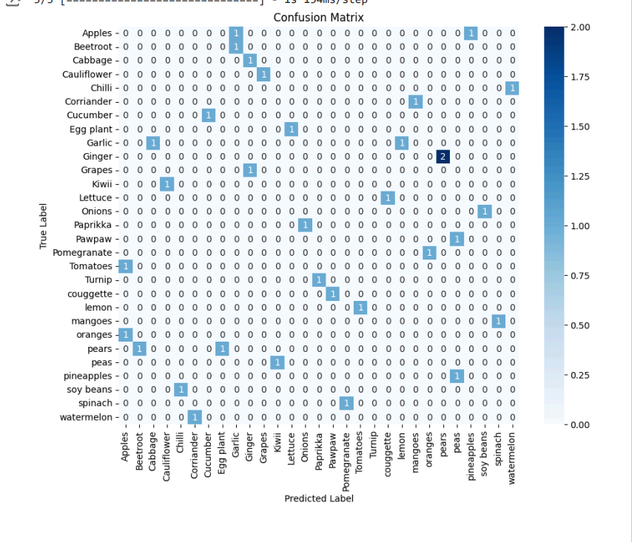
- A confusion matrix is a table that sums up the performance of a classification model. The confusion matrix shows the number of correct predictions: true positives (TP) and true negatives (TN). It helps visualize the frequency of each of them in a single place. This way, you can grasp the number of correct predictions and errors of each type simultaneously.
- It also shows the model errors: false positives (FP) are “false alarms,” and false negatives (FN) are missed cases. Taking an example in our project the model predicted once a tomato being an apple and twice Ginger being pears.

SOURCES OF ERRORS

1)Using fewer number of epochs, we started by using 5 epochs which greatly led to low accuracy of 0.3, however when the number of epochs were increased the model continues to refine its understanding of the training data. However, after a certain point, increasing the number of epochs can lead to overfitting, where the model becomes too focused on the training data and performs poorly on new, unseen data. This can cause the accuracy to decrease.
2)Fewer training parameters
3)Not doing data-preprocessing such as image cleaning and annotation; Lack of image cleaning may lead to low quality and poor feature extraction on the image such as edge features.
4)Using fewer layers in our model.
RECOMMENDATIONS
To use a pre-trained model such as VGG16, a pre-trained deep learning model that has been used for image classification in various domains. One advantage of using VGG16 is its ability to extract high-level features from images, which allows for accurate classification.
Collect more data: If possible, collecting more data for the classes that are causing the most errors can help improve the model's ability to distinguish between these classes.
Data Augmentation: If collecting more data is not feasible, data augmentation techniques can be used to artificially increase the size of the training dataset. This can help the model learn more robust features and improve its performance on the problematic classes.
Class Imbalance Techniques: If the two problematic classes are significantly smaller in size compared to the other classes, class imbalance techniques such as oversampling (duplicating instances of the minority class) or under sampling (removing instances from the majority class) can be used to balance the class distribution.
Feature Engineering: Analyze the features used in the model and consider creating new features or transforming existing ones that may better discriminate between the problematic classes.
Model Selection: Experiment with different types of models or algorithms to see if a different model performs better on the problematic classes. Some models may be better suited for handling imbalanced classes.
Hyperparameter Tuning: Optimize the hyperparameters of the model using techniques like grid search or random search to find the best set of hyperparameters that improve the model's performance on the problematic classes.
Ensemble Methods: Combine multiple models to create an ensemble model that can potentially improve the overall performance, especially on the problematic classes. Techniques like bagging or boosting can be used for this purpose.
Cost-sensitive Learning: Adjust the misclassification costs associated with different classes to penalize errors on the problematic classes more heavily, encouraging the model to focus on improving its performance on these classes.
Error Analysis: Conduct a thorough error analysis to understand why the model is making mistakes on the problematic classes. This can provide insights into what specific patterns or characteristics are causing confusion and guide further improvements

CONCLUSIONS
As we wrap this lab project, we did not achieve the maximum accuracy required this may have been caused by lack of enough datasets and fewer epochs, however doing transfer learning and data augmentation can improve the accuracy.
REFERENCES
1)Lecture Notes on AI&Ml by Dr. Muguro Joseph
2) Classifying Fruits and Vegetables with Machine Learning | CodeAI (medium.com)
3) Basics of CNN in Deep Learning - Analytics Vidhya

